7.2.1 Editors - 3D View - Header tools and Options
Detailed Table of content 1
Introduction 8
Mode Drop-down Box 8
Mesh Object Sub Modes 9
Grease Pencil Sub Modes 12
Object settings 14
Object Types Visibility 17
Viewport Gizmo 18
Show Overlays - all modes 20
Show Overlays - Mesh Object - Edit Mode 23
Show Overlays - Mesh Object - Sculpt Mode 27
Show Overlays - Mesh Object - Vertex Paint Mode 27
Show Overlays - Mesh Object - Weight Paint Mode 27
Show Overlays - Mesh Object - Texture Paint Mode 28
Show Overlays - Pose Mode 28
Show Overlays - Grease Pencil 28
Viewport Shading 29

Detailed Table of content

7.2.1 Editors - 3D View - Header tools and Options
Detailed Table of content 1
Introduction 8
Mode Drop-down Box 8
Object Mode 8
Edit Mode 8
Sculpt Mode 8
Vertex Paint 8
Weight Paint 9
Texture Paint 9
Edit Strokes 9
Particle Edit 9
Draw 9
Mesh Object Sub Modes 9
Edit Mode - Mesh Select Modes 9
Vertex Paint - Mask and Vertex Selection 10
Paint Mask 10
Vertex Selection 10
Weight Paint - Mask and Vertex Selection 10
Paint Mask 10
Vertex Selection 11
Texture Paint - Mask Selection 11
Paint Mask 11
Particle Edit - Select Modes 12
Mesh Object with a particle system. You can just have one method active at a time. 12
Path 12
Point 12
Tip 12
Grease Pencil Sub Modes 12
Edit Mode 12
Select Modes 12
Select Only Points 12
Select all Stroke Points 12
Select all Stroke Points between other strokes 12
Multiframe 13
Use Falloff 13
Selection Mask 13
Interpolate 13
Sculpt Mode 13
Selection Mask 13
Multiframe 13
Use Falloff 13
Draw Mode 13
Draw Strokes on Back 13
Add Weight Data for new strokes 13
Use Additive Drawing 14
Weight Paint Mode 14
Multiframe 14
Use Falloff 14
Object settings 14
Transform Orientations 14
View 14
Gimbal 15
Normal 15
Local 15
Global 15
Cursor 15
Create Orientation 15
Last Operator Create Orientation 15
Name 15
Use View 15
Use after creation 15
Overwrite Previous 15
Pivot Point 16
Only Origins 16
Snapping 16
Snapping Settings 16
Absolute Grid Snap 16
Affect 16
Proportional Editing 16
Settings 16
Proportional Size 17
Last Operator Proportional Editing 17
Proportional Editing 17
Proportional Falloff 17
Proportional Size 17
Object Types Visibility 17
Viewport Gizmo 18
Show Gizmo 18
Gizmo Options 18
Viewport Gizmos 18
Navigate 18
Active Tools 18
Active Object 18
Object Gizmos 18
Transformation Orientation 18
Move 19
Rotate 19
Scale 19
Empty 19
Image 19
Force Field 19
Light 19
Size 19
Look At 19
Camera 20
Lens 20
Focus Distance 20
Show Overlays - all modes 20
Guides 20
Grid 20
Floor 20
Axes 20
Scale and Subdivisions 20
Text Info 20
Annotations 21
3D Cursor 21
Objects 21
Extras 21
Relationship Lines 21
Outline Selected 21
Bones 21
Motion Paths 21
Origins 21
Origins(All) 22
Geometry 22
Wireframe 22
Face Orientation 22
Motion Tracking 22
Camera Path 22
Marker Names 22
Track display type 22
Track size 22
Show Overlays - Mesh Object - Edit Mode 23
Mesh Edit Mode 23
Edges 23
Faces 23
Center 23
Creases 23
Sharp 23
Bevel 23
Seams 23
Developer 23
Indices 23
Shading 24
Hidden Wire 24
Vertex Groups Weights 24
Zero Weights 24
None 24
Active 24
All 24
Mesh Analysis 24
Overhang 24
Minimum/Maximum 24
Axis 24
Thickness 24
Minimum/Maximum 25
Samples 25
Intersections 25
Distortion 25
Minimum/Maximum 25
Sharp Edges 25
Minimum/Maximum 25
Measurement 26
Edge Length 26
Edge Angle 26
Face Area 26
Face Angle 26
Normals 26
Size 26
Freestyle 26
Edge Marks 26
Face Marks 26
Show Overlays - Mesh Object - Sculpt Mode 27
Mask 27
Show Overlays - Mesh Object - Vertex Paint Mode 27
Opacity 27
Show Wire 27
Show Overlays - Mesh Object - Weight Paint Mode 27
Opacity 27
Zero Weights 27
None 27
Active 27
All 27
Show Weight Contours 27
Show Wire 27
Show Overlays - Mesh Object - Texture Paint Mode 28
Stencil Opacity 28
Show Overlays - Pose Mode 28
Fade Geometry 28
Show Overlays - Grease Pencil 28
In Object Mode 28
Onion Skin 28
Canvas 28
Fade 3D Objects 28
In Edit, Sculpt and Weightpaint Mode 28
Edit Lines 28
Show Edit Lines only in multiframe 28
Vertex Opacity 29
In Draw Mode 29
Fade Layers 29
Viewport Shading 29
Show X Ray 29
Viewport Shading 29
Wireframe 29
Solid 29
Material 29
Rendered 30
Viewport Shading Settings 30
Viewport Shading Settings with Wireframe 30
Color 30
Single 30
Object 30
Random 30
Background 30
Theme 30
World 30
Viewport 30
Options 30
Show X Ray 30
X Ray Alpha 31
Outline 31
Outline Color 31
Viewport shading Settings with Solid 31
Lighting 31
Studio 31
World Space Lighting 31
Rotation 31
Show Light Preferences 31
Color 32
Material 32
Object 32
Vertex 32
Single 32
Random 32
Texture 32
Background 32
Theme 32
World 32
Viewport 32
Options 32
Backface Culling 32
Show X Ray 33
X Ray Alpha 33
Shadow 33
Shadow Intensity 33
Light Settings 33
Light Direction 33
Shadow Shift 33
Shadow Focus 33
Cavity 33
Type 33
World 33
World Space / Ridge Valley 33
Shading Options 34
Screen 34
Screen Space / Ridge Valley 34
Both 34
Outline 34
Outline Color 34
Specular Lighting 34
Matcap 34
Show Light Preferences 34
Flip Matcap 35
Color 35
Material 35
Object 35
Vertex 35
Single 35
Random 35
Texture 35
Background 35
Theme 35
World 35
Viewport 35
Options 36
Backface Culling 36
Show X Ray 36
X Ray Alpha 36
Shadow 36
Shadow Intensity 36
Light Settings 36
Light Direction 36
Shadow Shift 36
Shadow Focus 36
Cavity 36
Type 36
World 37
World Space / Ridge Valley 37
Shading Options 37
Screen 37
Screen Space / Ridge Valley 37
Both 37
Outline 37
Outline Color 37
Flat 37
Color 37
Material 37
Object 37
Vertex 37
Single 38
Random 38
Texture 38
Background 38
Theme 38
World 38
Viewport 38
Options 38
Backface Culling 38
Show X Ray 38
X Ray Alpha 38
Shadow 38
Shadow Intensity 39
Light Settings 39
Light Direction 39
Shadow Shift 39
Shadow Focus 39
Cavity 39
Type 39
World 39
World Space / Ridge Valley 39
Shading Options 39
Screen 39
Screen Space / Ridge Valley 39
Both 39
Outline 40
Outline Color 40
Specular Lighting 40
Viewport Shading with Look Dev 40
Lighting 40
Scene Lights 40
Scene World 40
hdr file browser 40
Show light preferences 40
Rotation 40
Background 40
Viewport Shading with Rendered 41
Pause Preview 41

Introduction

The header in the 3D view contains various menus and tools. This chapter here is about the tools, modes and options elements in the header.

The text menus are covered in a own chapter each. They vary too much, dependant of mode and object type.

Mode Drop-down Box

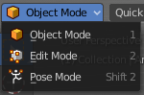
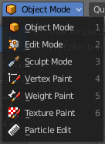
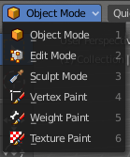
The Mode drop-down box allows you to switch between the different modes.

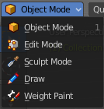
Modes are object states that allows you to edit and manipulate objects at different levels with different tool sets and goals. The sculpt mode for example allows you to sculpt a mesh object. Edit Mode allows to manipulate the mesh of the object, and so on.

The available modes can differ from object to object. A armature for example has an additional pose mode. And when you work with a grease pencil object, then several grease pencil modes becomes available.

Object Mode
This mode allows to manipulate objects at Object level. Like move it around, rotate it, etc. This mode is available for all object types.

Edit Mode
The edit mode allows to edit the object. With a mesh object this means that you are able to modify and to change the geometry. With an armature you build your skeleton. And with a text object you can type in text, and choose the font etc.
Not all objects has an edit mode.

Sculpt Mode
In this mode you can sculpt the mesh. This mode is available for mesh and grease pencil objects.

Vertex Paint
Vertex Paint is a mesh object only mode. In this mode you can paint vertices with colors.

Weight Paint
In this mode you can adjust weight painting for an armature for example. But Weight Painted mesh objects can also be used in conjunction with particles. Also a grease pencil stroke can be weight painted.

Texture Paint
Weight Paint is a mesh object only mode. In this mode you can paint at the texture of a mesh directly. This mode requires to have a working UV mapping and a texture at the mesh object.

Edit Strokes
Edit Strokes is a Grease Pencil only mode. It allows to manipulate the curves at a mesh level.

Particle Edit
Particle edit is a Particle System mode only. When you apply a particle system to a mesh object then this mode becomes available. It allows you to manipulate the particle system at a mesh level. You can comb hair particles for example.

Draw
Draw is a grease pencil object only mode. In this mode you draw grease pencil strokes.

Mesh Object Sub Modes

The different modes can have some submodes. For example different selection methods in mesh edit mode. Or a mask mode for texture painting. The sub mode settings can be found right from the Modes dropdown box.

Edit Mode - Mesh Select Modes
When you enter the edit mode with a mesh object then you will see the mesh select modes. They allows you to switch between the three available selection modes Vertice select, Edge Select and Face Select.

Vertex Select allows you to select vertices.
Edge Select allows you to select edges.
Face select allows you to select faces.

The mesh display changes, dependant of the mode. When you have for example select vertices active, then the vertices hilights at the mesh.

You can have more than one mode active by shift clicking at the other mesh select modes.
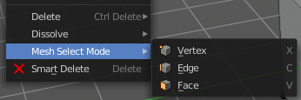
The standard Bforartists has hotkeys to switch between the modes. X, C and V. You cannot see or edit them at the header element. There is however a sub menu in the mesh menu, called Mesh Select Mode. Here you can see and edit the hotkeys.

Vertex Paint - Mask and Vertex Selection

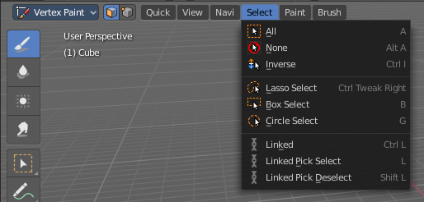
Paint Mask
When you activate this tool then you reveal a Select menu in the header. And you can select the mesh parts that you want to manipulate. Note that you may first want to deselect all. By default everything is selected ...

The select menu is explained in the chapter Vertex Paint modes. The menu items should be pretty self explaining though.
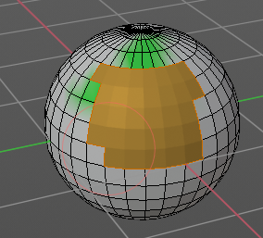

When you have selected a part of the mesh, then you can just paint the faces at this selected part. The edges are the border.

Vertex Selection
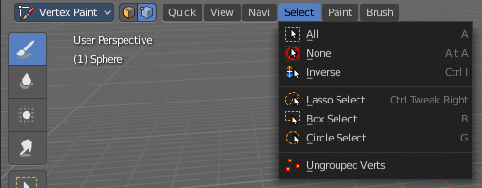
When you activate this tool then you reveal a Select menu in the header. And you can select the mesh parts that
you want to manipulate. This tool is meant for Weight Painting. And so the mesh displays the vertices too.
Note that you may first want to deselect all. By default everything is selected ...

The select menu is explained in the chapter Vertex Paint modes. The menu items should be pretty self explaining though.

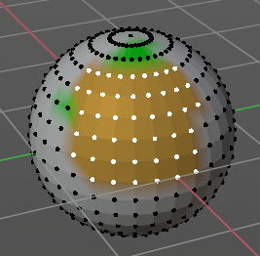
When you have selected a part of the mesh, then you can just paint the vertices at this selected part. The difference to the Paint mask method is that here the edges are not the border of the color. But there is a gradient between the vertices.

Weight Paint - Mask and Vertex Selection

Paint Mask
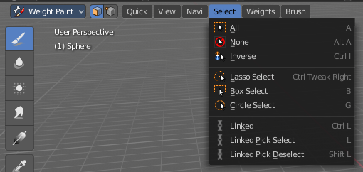
Mesh Object.
When you activate this tool then you reveal a Select menu in the header. And you can select the mesh parts that you want to manipulate. Note that you may first want to deselect all. By default everything is selected ...

The select menu is explained in the chapter Vertex Paint modes. The menu items should be pretty self explaining though.

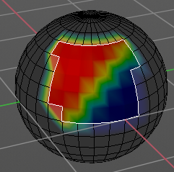
When you have selected a part of the mesh, then you can just paint the faces at this selected part. The edges are the border.

Vertex Selection
Mesh Object.
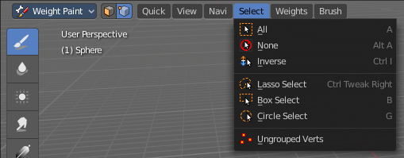
When you activate this tool then you reveal a Select menu in the header. And you can select the mesh parts that
you want to manipulate. This tool is meant for Weight Painting. And so the mesh displays the vertices too.
Note that you may first want to deselect all. By default everything is selected ...

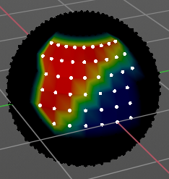
The select menu is explained in the chapter Vertex Paint modes. The menu items should be pretty self explaining though.

When you have selected a part of the mesh, then you can just paint the vertices at this selected part. There is no real difference to the faces method. The selection is the same.

Texture Paint - Mask Selection

Paint Mask
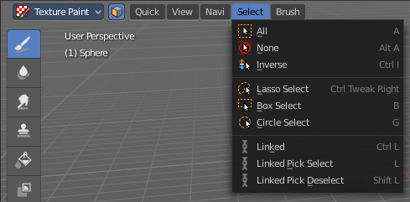
Mesh Object.
When you activate this tool then you reveal a Select menu in the header. And you can select the mesh parts that you want to manipulate. Note that you may first want to deselect all. By default everything is selected ...

The select menu is explained in the chapter Vertex Paint modes. The menu items should be pretty self explaining though.

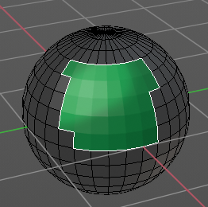
When you have selected a part of the mesh, then you can just paint the faces at this selected part. The edges are the border.

Particle Edit - Select Modes

Mesh Object with a particle system. You can just have one method active at a time.

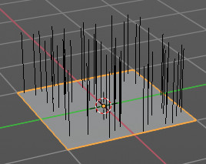
Path
No keypoints are visible, you can select/deselect only all particles.

Point
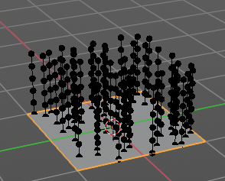
You can see, select and edit all keypoints of the particle paths.

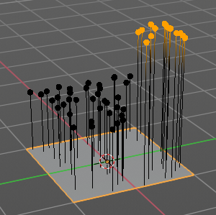
Tip
You can onyl see, select and edit the tip of the particles. This includes the brushes. The comb brush is a special case here. The other pat keypoints bends of course still in this mode. But affected by the brush is just the tip key.

Grease Pencil Sub Modes

The different modes can have some submodes. For example different selection methods in mesh edit mode. Or a mask mode for texture painting. The sub mode settings can be found right from the Modes dropdown box.

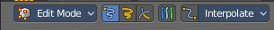
Edit Mode
The edit mode allows you to edit the grease pencil strokes.

Select Modes
You can only have one method active at a time.

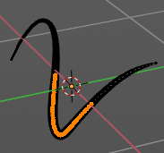
Select Only Points
When you for example border select some points of the stroke, then just this points gets selected.

Select all Stroke Points
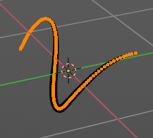
When you for example border select some points of the stroke, then the whole stroke gets selected.

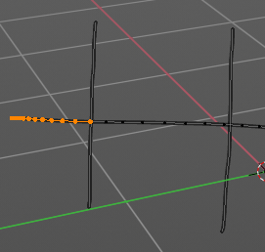
Select all Stroke Points between other strokes
When you for example border select some points of the stroke, and this stroke crosses another stroke, then the part of the stroke up to the crossing point gets selected.

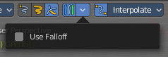
Multiframe
When this mode is active, then you can edit strokes from multiple grease pencil frames at once. The keyframes must be selected to be included.

Use Falloff
Multiframe has a setting, which becomes visible when the mode is active.
Use Falloff when edit in Multiframe mode to compute brush effect by frame.

Interpolate Panel
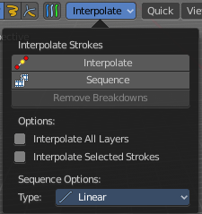
When you are animating simple shapes you can use the interpolate tools to automatically add new breakdown keyframes.

Interpolate
Interpolates strokes between the previous and next keyframe by adding a single keyframe. When you are on a frame between two keyframes and click the Interpolate button a new breakdown keyframe will be added. This way you define the final interpolation for the new stroke.

Sequence
Interpolate strokes between the previous and next keyframe by adding multiple keyframes. When you are on a frame between two keyframes and click the sequence button a breakdown keyframe will be added on every frame between the previous and next keyframe.

Remove Breakdowns
Removes the breakdowns generated by the interpolate tool. When there is no breakdown pose then the button is greyed out.

Interpolate All Layers
When enabled, interpolated keyframes will be created on all layers, not only the active one.

Interpolate Selected Strokes
When enabled, only selected strokes will be interpolated.

Type
Interpolation method to use for the sequence.

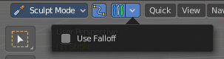
Sculpt Mode
The sculpt mode allows you to sculpt the grease pencil strokes.

Selection Mask
When you activate this mode, then just the selected parts gets sculpted.

Multiframe
When this mode is active, then you can edit strokes from multiple grease pencil frames at once. The keyframes must be selected to be included.

Use Falloff
Multiframe has a setting, which becomes visible when the mode is active.
Use Falloff when edit in Multiframe mode to compute brush effect by frame.

Draw Mode
The draw mode is the mode in which you draw the grease prencil strokes.

Draw Strokes on Back
Usually a new stroke is drawn on top of existing strokes. Draw Strokes on Back adds the new strokes below the existing strokes.

Add Weight Data for new strokes
Add Weight data for new strokes, according to the current vertex group and weight. When no vertex group is selected, then no weight is added.

Use Additive Drawing
When creating new frames, then thhe strokes from the previous or active frame gets included as the base for the new stroke.

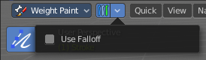
Weight Paint Mode

Multiframe
When this mode is active, then you can edit strokes from multiple grease pencil frames at once. The keyframes must be selected to be included.

Use Falloff
Multiframe has a setting, which becomes visible when the mode is active.
Use Falloff when edit in Multiframe mode to compute brush effect by frame.

Object settings

The object settings just appears when the Tool Settings are hidden. This can be done in the View menu.
The object settings are just visible in Object and Edit Mode.

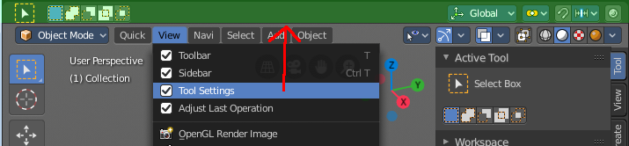

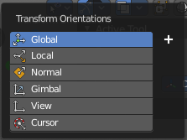
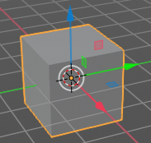
Transform Orientations
You can display Transform Manipulators at your object or selection by activating them in the tool shelf. They allow you to scale, rotate or move objects by grabbing their controls, and moving your mouse in the corresponding axis. The widget can be oriented in different ways by using another method in this dropdown box. The names should be self explaining.

View
The transform orientation aligns to the current view.

Gimbal
Aligns each axis to the Euler rotation axis as used for input.

Normal
This is of interest for bones for example. Aligns the transformation axis to average normal of the selected elements. Bone Y axis for Pose mode.

Local
Uses the local orientation of the selected elements.

Global
Uses the global orientation for the selected elements.

Cursor
Uses the orientation of the 3D cursor.

Create Orientation
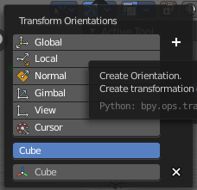
The create orientation button at the right adds a new orientation from the current mode and view. You can rename it.

This view is scene specific only. It does save and load with the current scene. But you cannot transfer it into another scene. When you create a new scene then this custom orientation is gone.

You can create more than one user orientation.

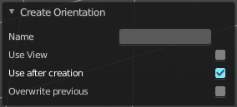
Last Operator Create Orientation
Create Orientation has some settings.

Name
Here you can rename the orientation.

Use View
Use the current view instead of the active object to create the new orientation.

Use after creation
Use this orientation after creation.

Overwrite Previous
Overwrite previous created orientation in case it has the same name.

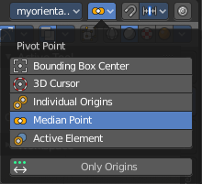
Pivot Point
The Pivot Point is the center of your object or your selection. When you rotate or scale an object, or a group of vertices/edges/faces, you may want to shift the pivot point in 3D space. The names should be self explaining.

Only Origins
When this option is enabled, then the transformation will change the positions of the object’s origins, but will not affect the object itself.

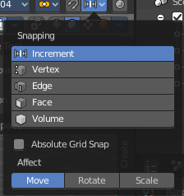
Snapping
Here you can activate snapping.
Snapping can be temporarily activated by holding CTRL key. So no need to turn snapping on and off all the time. This counts for both transform methods. The old method with the W E R hotkeys, and the new method with the widgets.

Snapping Settings
You can snap to various scene elements. Here you can define to which other elements the current active element should snap to. The names should be self explaining. Increment snaps by a grid unit.

Absolute Grid Snap
Absolute Grid alignment while transform. Relative Grid snapping would add to the current position by one unit. Absolute snaps to the nearest ground grid point.

Affect
Here you can adjust what transform methods should be affected by snapping.

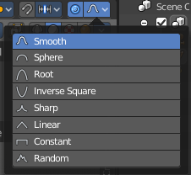
Proportional Editing
Enables proportional editing.
Proportional Editing is a way of transforming selected elements (such as vertices) while having that transformation affect other nearby elements with a falloff. For example, moving a single vertex will move unselected vertices within a given range. And the falloff means that nselected vertices that are closer to the selected vertex will move more than those farther from it.

Settings
The settings appears when you activate Proportional Editing. Here you can choose between different falloff methods for the proportional editing.

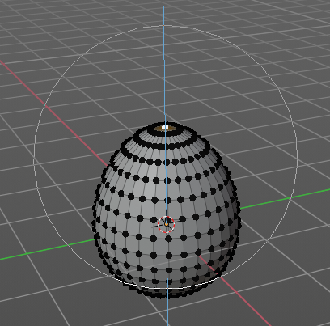
Proportional Size
The influence of the proportional editing is defined by a radius. It is by default one standard unit.
You can change the influence radius for proportional editing with the mouse wheel or the Page up Page down arrows while keeping the mouse button pressed down and do the translation.

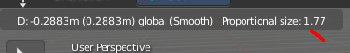
The exact radius value can be read in the header while transformation.

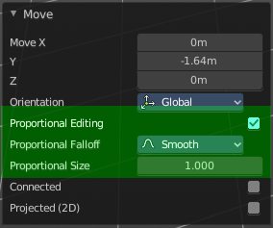
Last Operator Proportional Editing

When you translate a object, move it around or rotate or scale it, then the last operator contains also proportional editing settings.

Proportional Editing
Enable proportional editing.

Proportional Falloff
Here you can adjust the falloff methods again.

Proportional Size
Here you can see and adjust the falloff radius. Note that the white circle is not displayed when using this slider.

Connected
The proportional falloff gets calculated for connected parts only.

Projected(2D)
In depth direction along the view the radius is ignored. It selects as deep as there is something to select.

Object Types Visibility
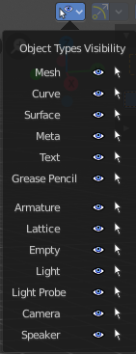
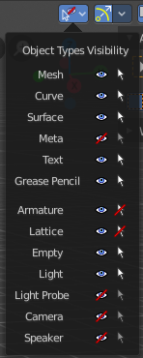
In this dropdown box you can set specific elements in the scene to either not selectable or invisible.

When the elements are invisible then they are also not selectable.

When you have set some objects to not selectable or invisible, then the icon in the menu header changes.

Viewport Gizmo
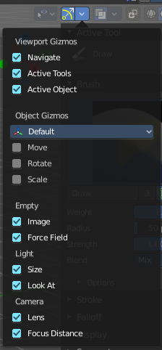
This menu allows you to adjust what gizmos shows. The button at the left turns off or on all of them.

Show Gizmo
Shows or hides all available gizmos at once.

Gizmo Options
Here you can turn on or off specific widgets.

Viewport Gizmos

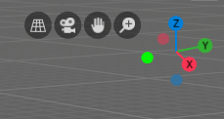
Navigate
Turn on or off the navigate widget. The navigate gizmo is the block of buttons and the widget up right.

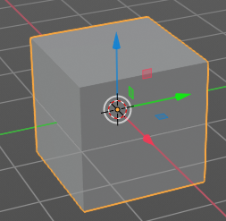
Active Tools
Turn on or off the active tool widget. When you activate one of the transformation buttons in the tool shelf, then a gizmo will appear at the object.

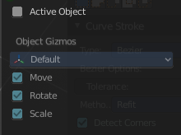
Active Object
Turn on or off the Object Gizmos. The Object Gizmos is an extra set of translate gizmos, similar to the active tool widget that shows when you activate one of the transform buttons in the tool shelf. But it shows permanent as long as you don't have another tool selected that overrides this widget.

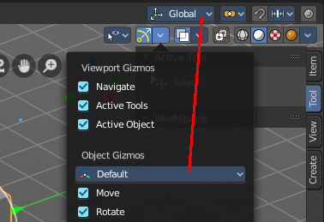
Object Gizmos

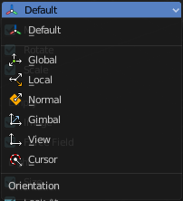
Transformation Orientation
Here you can adjust the orientation of the widget. By default it uses the transform orientation from the viewport. This set can override the transform orientation.
You can have all transform methods on at once.

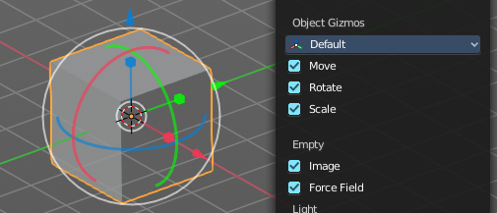
Move
Shows the move part of the widget.

Rotate
Shows the rotate part of the widget.

Scale
Shows the scale part of the widget.

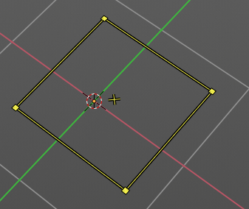
Empty

Image
Shows the transform gizmo at an empty of type Image. You need to hover with the mouse over the object to reveal the yellow gizmo.

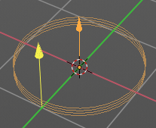
Force Field
Some force field types have a gizmo. Shows the transform gizmo at a force field.

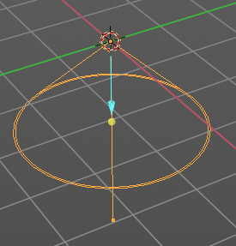
Light

Size
Show the gizmo to adjust the size of lights. That's the blue arrow here.

Look At
Show the gizmo to adjust the direction of the light. That's the yellow dot in the middle of the circle.

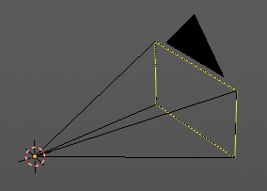
Camera

Lens
Show the gizmo to adjust the lens and orthographic size. The yellow square.

Focus Distance
Show to gizmo to adjust the focus distance.
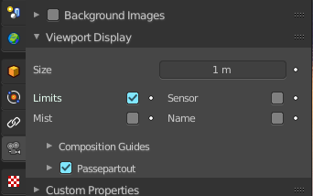
You first need to turn on the Limits gizmo in the camera settings in the Viewport Display panel. Then you can turn off the focus distance gizmo part with Focus Distance.
Note that this feature is currently broken!

Show Overlays - all modes
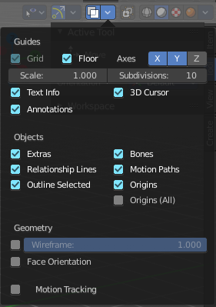
Here you can turn on or off all overlays. This includes the ground grid, things like relationship lines, and several other elements in the viewport. Some content is available in all modes. Some content is changing, dependant of the mode you are in. In Edit mode with a mesh object you will get some normal functionality for example.

Guides

Grid
Show grid in the orthographic views. When you are in perspectivic view, then this feature is greyed out.

Floor
Show the ground grid in the perspectivic views.

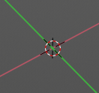
Axes
Show the colored axis lines in the 3d view. This feature just works in perspectivic view. In orthographic view this lines cannot be hidden separately.

Scale and Subdivisions
Here you can scale and subdivide the ground grid. This works in perspectivic and orthographic view.

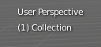
Text Info
In the upper left corner of the 3D view there is a text info string, which can be hidden here. It tells you in what view you are, what is selected, and things like frames per second when you play a animation.

Annotations
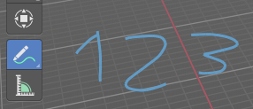
Show or hide annotations. Annotations can be drawn at the 3D View with the annotation tool in the tool shelf.

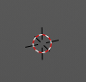
3D Cursor
Show or hide the 3D cursor. That's the white red circle in the center of the viewport.

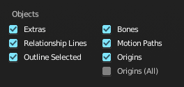
Objects

Extras
Show or hide object details. Including things like empty wires like lights, cameras, and other visual guides.

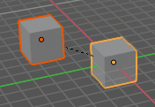
Relationship Lines
Show or hide relationship lines. When you for example parent one object to another then you will see a dotted line. The relationship line.

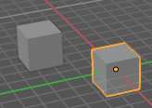
Outline Selected
Show the selected object with a outline.

Bones
Show or hide bones.

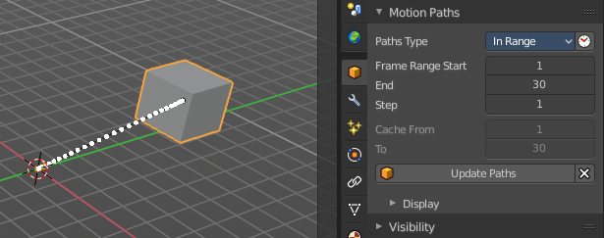
Motion Paths
Show or hide motion paths. Motion paths can be calculated in the Motion Paths panel. You need a animation for that.

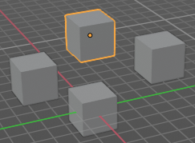
Origins
Show or hide the origin of the selected object. The origin is the center point of the object, and represented by a orange dot.

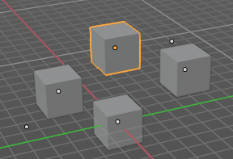
Origins(All)
Show or hide the origin of all objects. Even from hidden ones. The not selected objects shows the center point with a white dot.

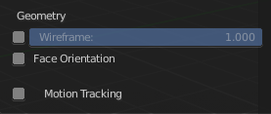
Geometry
Geometry related settings.

Wireframe
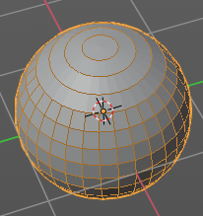
Here you can show the wireframe in object mode. With a wireframe value of 1 all edges are drawn. The lower the value, the more edges will disappear.

Face Orientation
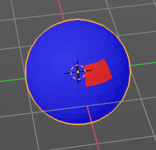
This mode allows to check for faces with flipped normals, which cannot be seen with the defaults. Blue is pointing outwards, red is pointing inwards.

Motion Tracking
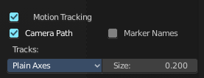
Here you can find some motion tracking related settings. When you turn it on, then some further options appears. These features just shows before you bake the solution. Not with the resolved solution.

Camera Path
Shows the camera path.

Marker Names
Shows the marker names.

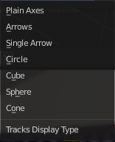
Track display type
How to display the tracks.

Track size
Here you can adjust the display size of the tracks of reconstructed data.

Show Overlays - Mesh Object - Edit Mode

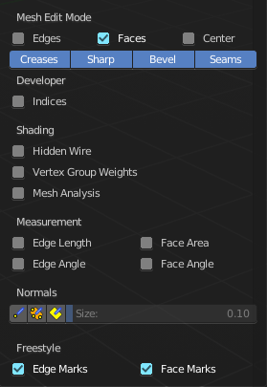
The Show overlays panel shows different content, dependant of mode and object type. This is with mesh object in edit mode.

Mesh Edit Mode

Edges
Highlight selected and partially selected edges.
This only affects vertex and face selection mode (as edges are always highlighted in edge-selection mode).

Faces
Highlight faces by using a face overlay that applies to both selected and unselected faces.
This affects all selection modes.

Center
Show face-center points in solid shading modes.
Only affects face-select mode.

Creases
Display edges marked with a crease for the Subdivision Surface Modifier.

Sharp
Display sharp edges, used with the edge split modifier.

Bevel
Display weights created for the Bevel Modifier.

Seams
Display the UV unwrapping seams.

Developer

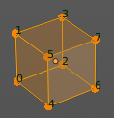
Indices
Display the indices of selected vertices, edges and faces at the mesh.

Shading

Hidden Wire
Show only front-facing wireframes.

Vertex Groups Weights
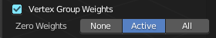
Display weights in Edit Mode. When you activate this feature then further options appears.

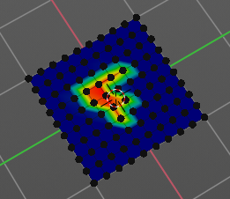
Zero Weights

None
Don't show the vertices with zero weights with a specific color. They appear blue like vertices with a very low weighting.

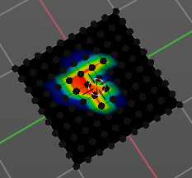
Active
Zero weights vertices are shown with a black color in the active vertex group.

All
Zero weights vertices are shown with a black color in all vertex groups of the mesh.

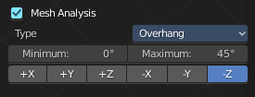
Mesh Analysis
Show the mesh analysis overlay and settings. Note that editing may be slow with mesh analysis tools on. And modifiers can make trouble.

Overhang
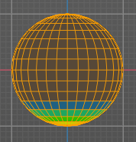
Extrusion 3D printers have a physical limit to the overhang that can be printed. Overhang mode shows the overhang. Angle and axis can be adjusted.

Minimum/Maximum
Minimum/Maximum angle to display.

Axis
Here you can choose wich angle to calculate.

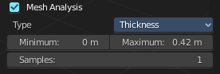
Thickness
3D Printers have a limited wall-thickness. Too thin areas cannot be printed. This mode displays thin areas as red.

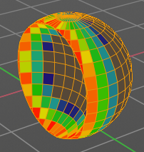
Minimum/Maximum
Minimum/Maximum thickness to display.

Samples
The number of samples to use to calculate the thickness.

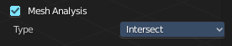
Intersections
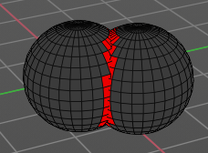
A mesh can be made of more than one closed submesh. Join two spheres and you have one mesh with two closed submeshes. Such intersections can be a problem with printing. Intersect marks intersecting areas with red.

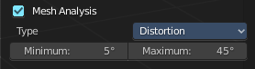
Distortion
Marks distorted faces.
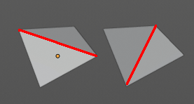
Distorted geometry, means uneven quads or n-gons, can cause problems with printing. Since the triangulation of a distorted quad or n-gon is undefined. And printing works with tris. With a quad there are already two solutions in which direction the edge to triangulate the face can point.

Minimum/Maximum
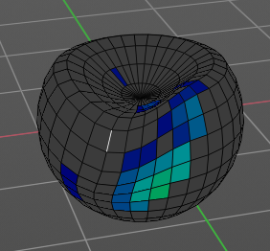
Here you can adjust the minimum and maximum values after which a face gets displayed as distorted.

Sharp Edges
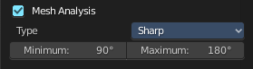
Similar to wall-thickness, sharp edges can be too thin to be able to print.

Minimum/Maximum
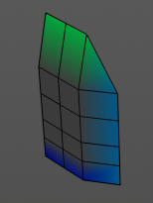
Here you can adjust the minimum and maximum values after which a edge gets displayed as sharp.

Measurement
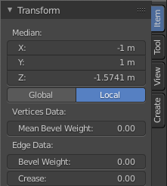
Shows measure values at the selected elements. The units are displayed as chosen in the preferences. These values respects global/ local in the transform panel. And so the values can differ when you have scaled the mesh in object mode, and the scaling is not applied yet. Use Global to take the object scale into account.

Edge Length
Shows the length of selected edges.

Edge Angle
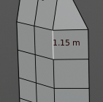
Shows the angle of selected edges between two faces.

Face Area
Show the area of selected faces.

Face Angle
Show the angle of selected face corners.

Normals
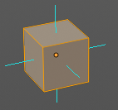
Show the normals for the chosen elements. They will be displayed as lines.
Display vertex normals
Display face normals at vertices (split normals)
Display face normals

Size
Here you can adjust the length of the line that represents the normal.

Freestyle
Freestlye is the line renderer integrated into Bforartists. For freestyle you can mark edges and faces.

Edge Marks
Display Freestyle edge marks, used with the Freestyle renderer.

Face Marks
Display Freestyle face marks, used with the Freestyle renderer.

Show Overlays - Mesh Object - Sculpt Mode

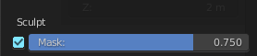
Mask
Show mask as overlay on object. The opacity of the overlay can be controlled.

Show Overlays - Mesh Object - Vertex Paint Mode

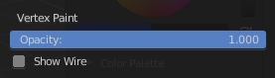
Opacity
How strong the painted color gets shown.

Show Wire
Display the wire at the mesh. Normally the wire is hidden.

Show Overlays - Mesh Object - Weight Paint Mode

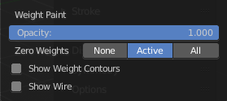
Opacity
The opacity of the color overlay.

Zero Weights

None
Don't show the vertices with zero weights with a specific color. They appear blue like vertices with a very low weighting.

Active
Zero weights vertices are shown with a black color in the active vertex group.

All
Zero weights vertices are shown with a black color in all vertex groups of the mesh.

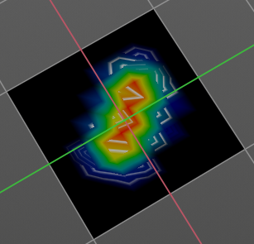
Show Weight Contours
Show contour lines formed by points with the same interpolated weight.

Show Wire
Display the wire at the mesh. Normally the wire is hidden.

Show Overlays - Mesh Object - Texture Paint Mode

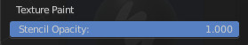
Stencil Opacity
How strong the painted color gets shown.

Show Overlays - Pose Mode

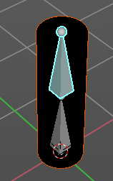
Fade Geometry
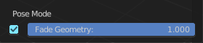
This has in general nearly the sameffect than draw in front. It shows the bones on top of the mesh geometry. But you can fade the mesh geometry to black.

Show Overlays - Grease Pencil

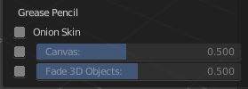
In Object Mode

Onion Skin
Show ghosts of the keyframes before and after the current frame.

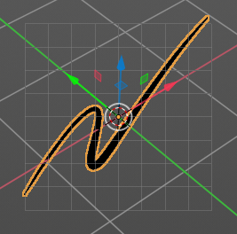
Canvas
Display a grid over Grease Pencil drawing plane. The opacity of the grid can be controlled with a slider.

Fade 3D Objects
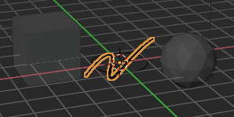
Fades everything in the viewport but the grease pencil color to black.

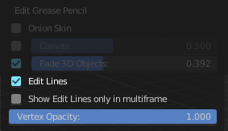
In Edit, Sculpt and Weightpaint Mode

Edit Lines
Show the edges of the curve when editing strokes.

Show Edit Lines only in multiframe
Only show edges of the curve while in multiframe edition.

Vertex Opacity
How strong the selected vertices of the stroke shows.

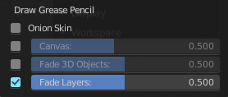

In Draw Mode

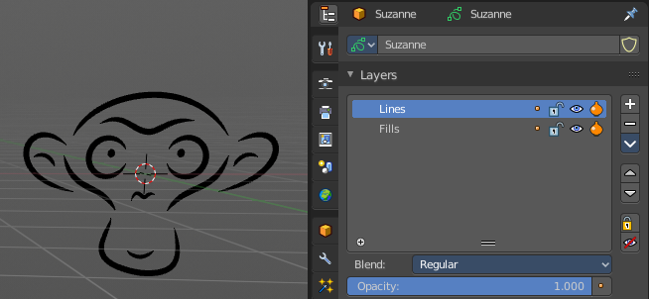
Fade Layers
Here you can decreases the opacity of the not selected layers in the current grease pencil object.

I have set the fade layers opacity to 1 here. When you select the other layer, then the inner part becomes visible again, and the black outlines hides.

Viewport Shading

At the very right of the header you can find the viewport shading settings. Here you adjust the display of the viewport. The order goes from left to right.

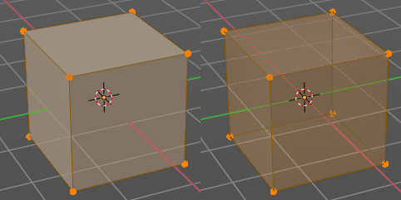
Show X Ray
This viewport setting is connected with the viewport shading. It allows you to show and edit the back geometry. Or hide it, so that you can just edit the geometry that points forwards.

Viewport Shading
Here you can define how geometry gets displayed in the viewport.

Wireframe
Displays the content in the viewport as Wireframe.

Solid
Displays the content in the viewport with a solid white color.

Material
Displays the content in the viewport with all material settings and with OpenGL rendering. Note that this does not exist when you choose the Workbench renderer.

Rendered
Displays the content in the viewport like you would have rendered it. This mode is dependant of what render engine you have currently active.

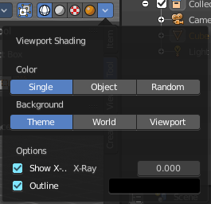
Viewport Shading Settings
The viewport shading panel. Its settings changes, dependant of which viewport shading mode you have activeated. And provides you with further settings for it.

Viewport Shading Settings with Wireframe

Color

Single
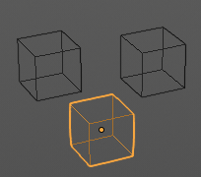
The selected object gets hilighted. The wireframe is the color of the selection outline. The not selected objects shows a black wireframe.

Object
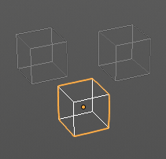
The selected object gets hilighted. The wireframe is white. The not selected objects shows a grey wireframe.

Random
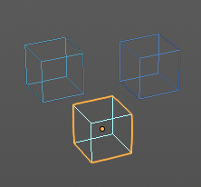
The selected object gets hilighted. The wireframe is a random wireframe color. The not selected objects shows a random wireframe color. You cannot influence this random color. It is random.

Background

Theme
Uses the viewport background color as defined in the theme.

World
Uses the world background color as the viewport background color.

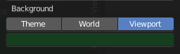
Viewport
Here you can define a custom color for the viewport background color.

Options

Show X Ray
This viewport setting is connected with the viewport shading. It allows you to show and edit the back geometry. Or hide it, so that you can just edit the geometry that points forwards.

X Ray Alpha
Here you can adjust the amount of transparency.

Outline
Show the not selected objects with an outline.

Outline Color
Here you can define the color of the outline for not selected objects.

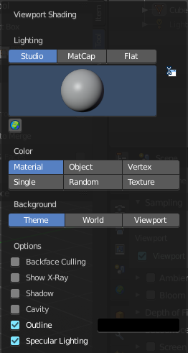
Viewport shading Settings with Solid

Lighting
Here you can choose between different lighting methods.
Note that this methods are not for rendering the scene. This lighting methods are meant to light the viewport.

Studio
Uses a studio setup lighting. You can choose between several studio light setups in the library menu below. This library menu is a box with a preview of the currently active light setup.
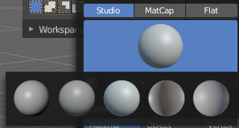

World Space Lighting
Make the lighting fixed to the world. And not follow the camera when you rotate around the scene.

Rotation
The rotation of the light setup. This edit box is just active when you use World Space Lighting.

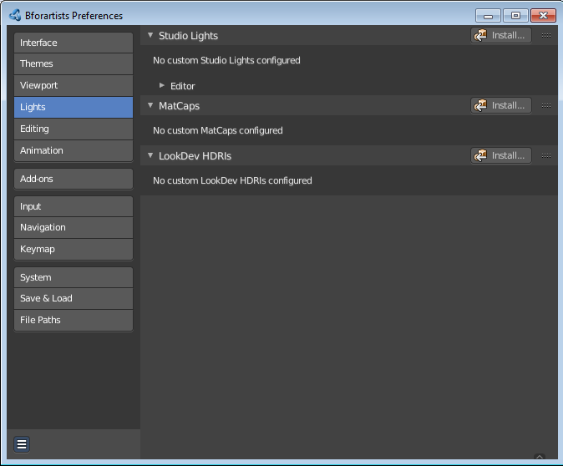
Show Light Preferences
At the right of the dropdown box you will see a tiny button. It will open the preferences, where you can edit the existing studio light setups, or add new Studio light setups. This chapter is explained in the preferences manual part.

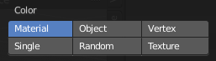
Color
Here you can further influence how the objects in the scene are colored. Just one setting can be active at one time.

Material
Uses the color of the material, in case a material is assigned to the object(s).

Object
Uses the Object color.

Vertex
Shows the vertex colors in case vertex colors exists.

Single
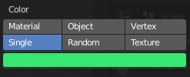
Here you can define a custom color. A color picker box appears when you activate single.

Random
Colors the objects with a random color

Texture
Shows the texture in case a material with a texture is assigned to the object(s).

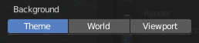
Background
Here you can define the look of the viewport background

Theme
Uses the background as defined in the theme.

World
Uses the background as defined in the world settings of the scene.

Viewport
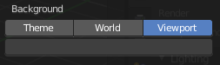
Use a custom color. When you activate this setting, then a colorpicker field appears, where you can adjust a custom color.

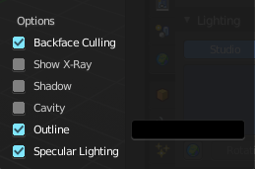
Options

Backface Culling
Use backface culling to hide backsides of faces.

Show X Ray
This viewport setting is connected with the viewport shading. It allows you to show and edit the back geometry. Or hide it, so that you can just see and edit the geometry that points forwards.
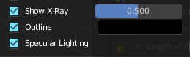
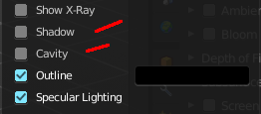
Note that you can either have Show X Ray active. Or Shadow and Cavity. When activating Show X Ray, the other two options will be hidden.

X Ray Alpha
Here you can adjust the strength of the transparency effect.

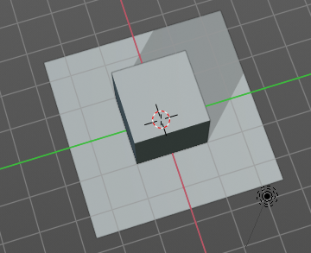
Shadow
Cast a shadow. Note that the shadow casting light is not part of the chosen studio light. It is an independant light.

Shadow Intensity
Here you adjust the strength of the shadow. Higher value means darker shadow.

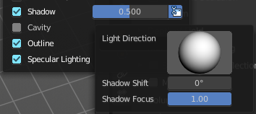
Light Settings
Here you can adjust some settings of the light.

Light Direction
Click into the field and drag the mouse to change the direction of the light that casts the shadow.

Shadow Shift
The shadow termination angle. This can be used to minimize self shadowing artefacts.

Shadow Focus
The shadow hardness. It controlls the fallowff near the edge of the shadow.

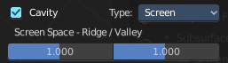
Cavity
Show Cavity. Cavity highlights ridges and valleys in the scene geometry. When you activate this setting, then further settings appears.

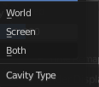
Type
The method how to calculate the cavity. In worlds pace, in screen space. Or in both.

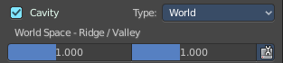
World
Draw the cavity shading in world space.

World Space / Ridge Valley
Factor for the cavity ridges and valleys.

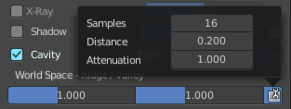
Shading Options
Here you can adjust samples, distance and attenuation for the cavity ridges and valleys.

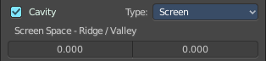
Screen
Draw the cavity shading in Screen space.

Screen Space / Ridge Valley
Factor for the curvature ridges and valleys.

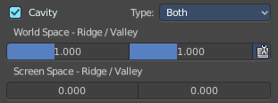
Both
Draw the cavity shading in both, World Space and Screen space.
Settings see above.

Outline
Show the not selected objects with an outline.

Outline Color
Here you can define the color of the outline for not selected objects.

Specular Lighting
Render specular highlights.

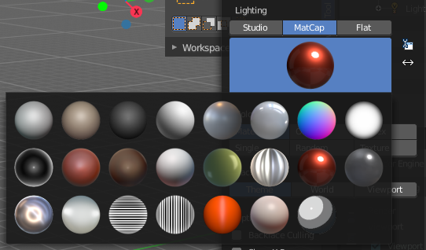
Matcap
Matcap stands for material capture. With Matcap you use a special matcap shader at the mesh. This shader is usually something colorful, which makes for example sculpting easier.
You can choose between several matcap setups in the library menu below. This library menu is a box with a preview of the currently active matcap setup.

Show Light Preferences
At the right of the library menu box you will see a tiny button. It will open the preferences, where you can edit the existing studio light setups, or add new Studio light setups. This chapter is explained in the preferences manual part.

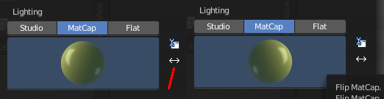
Flip Matcap
Some matcaps have a direction from which the light comes. With Flip Matcap you can flip this direction.

Color
Here you can further influence how the objects in the scene are colored. Just one setting can be active at one time.

Material
Uses the color of the material, in case a material is assigned to the object(s).

Object
Uses the Object color.

Vertex
Shows the vertex colors in case vertex colors exists.

Single
Here you can define a custom color. A color picker box appears when you activate single.

Random
Colors the objects with a random color

Texture
Shows the texture in case a material with a texture is assigned to the object(s).

Background
Here you can define the look of the viewport background

Theme
Uses the background as defined in the theme.

World
Uses the background as defined in the world settings of the scene.

Viewport
Use a custom color. When you activate this setting, then a colorpicker field appears, where you can adjust a custom color.

Options

Backface Culling
Use backface culling to hide backsides of faces.

Show X Ray
This viewport setting is connected with the viewport shading. It allows you to show and edit the back geometry. Or hide it, so that you can just see and edit the geometry that points forwards.
Note that you can either have Show X Ray active. Or Shadow and Cavity. When activating Show X Ray, the other two options will be hidden.

X Ray Alpha
Here you can adjust the strength of the transparency effect.

Shadow
Cast a shadow. Note that the shadow casting light is not part of the chosen studio light. It is an independant light.

Shadow Intensity
Here you adjust the strength of the shadow. Higher value means darker shadow.

Light Settings
Here you can adjust some settings of the light.

Light Direction
Click into the field and drag the mouse to change the direction of the light that casts the shadow.

Shadow Shift
The shadow termination angle. This can be used to minimize self shadowing artefacts.

Shadow Focus
The shadow hardness. It controlls the fallowff near the edge of the shadow.

Cavity
Show Cavity. Cavity highlights ridges and valleys in the scene geometry. When you activate this setting, then further settings appears.

Type
The method how to calculate the cavity. In worlds pace, in screen space. Or in both.

World
Draw the cavity shading in world space.

World Space / Ridge Valley
Factor for the cavity ridges and valleys.

Shading Options
Here you can adjust samples, distance and attenuation for the cavity ridges and valleys.

Screen
Draw the cavity shading in Screen space.

Screen Space / Ridge Valley
Factor for the curvature ridges and valleys.

Both
Draw the cavity shading in both, World Space and Screen space.
Settings see above.

Outline
Show the not selected objects with an outline.

Outline Color
Here you can define the color of the outline for not selected objects.

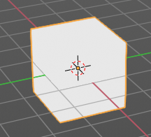
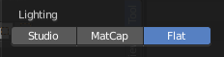
Flat
Lights the objects plain white.

Color
Here you can further influence how the objects in the scene are colored. Just one setting can be active at one time.

Material
Uses the color of the material, in case a material is assigned to the object(s).

Object
Uses the Object color.

Vertex
Shows the vertex colors in case vertex colors exists.

Single
Here you can define a custom color. A color picker box appears when you activate single.

Random
Colors the objects with a random color

Texture
Shows the texture in case a material with a texture is assigned to the object(s).

Background
Here you can define the look of the viewport background

Theme
Uses the background as defined in the theme.

World
Uses the background as defined in the world settings of the scene.

Viewport
Use a custom color. When you activate this setting, then a colorpicker field appears, where you can adjust a custom color.

Options

Backface Culling
Use backface culling to hide backsides of faces.

Show X Ray
This viewport setting is connected with the viewport shading. It allows you to show and edit the back geometry. Or hide it, so that you can just see and edit the geometry that points forwards.

Note that you can either have Show X Ray active. Or Shadow and Cavity. When activating Show X Ray, the other two options will be hidden.

X Ray Alpha
Here you can adjust the strength of the transparency effect.

Shadow
Cast a shadow. Note that the shadow casting light is not part of the chosen studio light. It is an independant light.

Shadow Intensity
Here you adjust the strength of the shadow. Higher value means darker shadow.

Light Settings
Here you can adjust some settings of the light.

Light Direction
Click into the field and drag the mouse to change the direction of the light that casts the shadow.

Shadow Shift
The shadow termination angle. This can be used to minimize self shadowing artefacts.

Shadow Focus
The shadow hardness. It controlls the fallowff near the edge of the shadow.

Cavity
Show Cavity. Cavity highlights ridges and valleys in the scene geometry. When you activate this setting, then further settings appears.

Type
The method how to calculate the cavity. In worlds pace, in screen space. Or in both.

World
Draw the cavity shading in world space.

World Space / Ridge Valley
Factor for the cavity ridges and valleys.

Shading Options
Here you can adjust samples, distance and attenuation for the cavity ridges and valleys.

Screen
Draw the cavity shading in Screen space.

Screen Space / Ridge Valley
Factor for the curvature ridges and valleys.

Both
Draw the cavity shading in both, World Space and Screen space.
Settings see above.

Outline
Show the not selected objects with an outline.

Outline Color
Here you can define the color of the outline for not selected objects.

Specular Lighting
Render specular highlights.

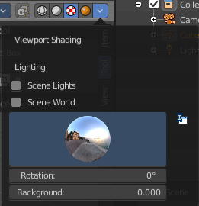
Viewport Shading with Look Dev
In this mode you can use a hdr file to light the scene.
This mode is just available with Cycles and Eevee renderer. Workspace renderer does not have this mode.

Lighting

Scene Lights
Use the scene lights instead of the hdr to light the scene.

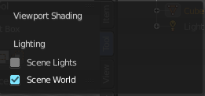
Scene World
Use the scene world to light the scene. This turns off the hdr. And the further options are not longer available.

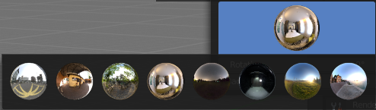
hdr file browser
Here you can pick a hdr file to light the world with.

Show light preferences
At the right of the library menu box you will see a tiny button. It will open the preferences, where you can edit the existing studio light setups, or add new Studio light setups. This chapter is explained in the preferences manual part.

Rotation
The rotation of the hdr file.

Background
Show the studiolight in the background. The higher the value the more the studio light gets mixed into the hdr.

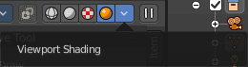
Viewport Shading with Rendered
With rendered shading the viewport uses the renderer settings of the chosen render engine. It has no specific shading settings therefore. And the panel is empty.
With Cycles it reveals one more button at the right though. Pause Preview.

Pause Preview
Pauses the rendering in the viewport when Cycles is chosen as the viewport renderer.

